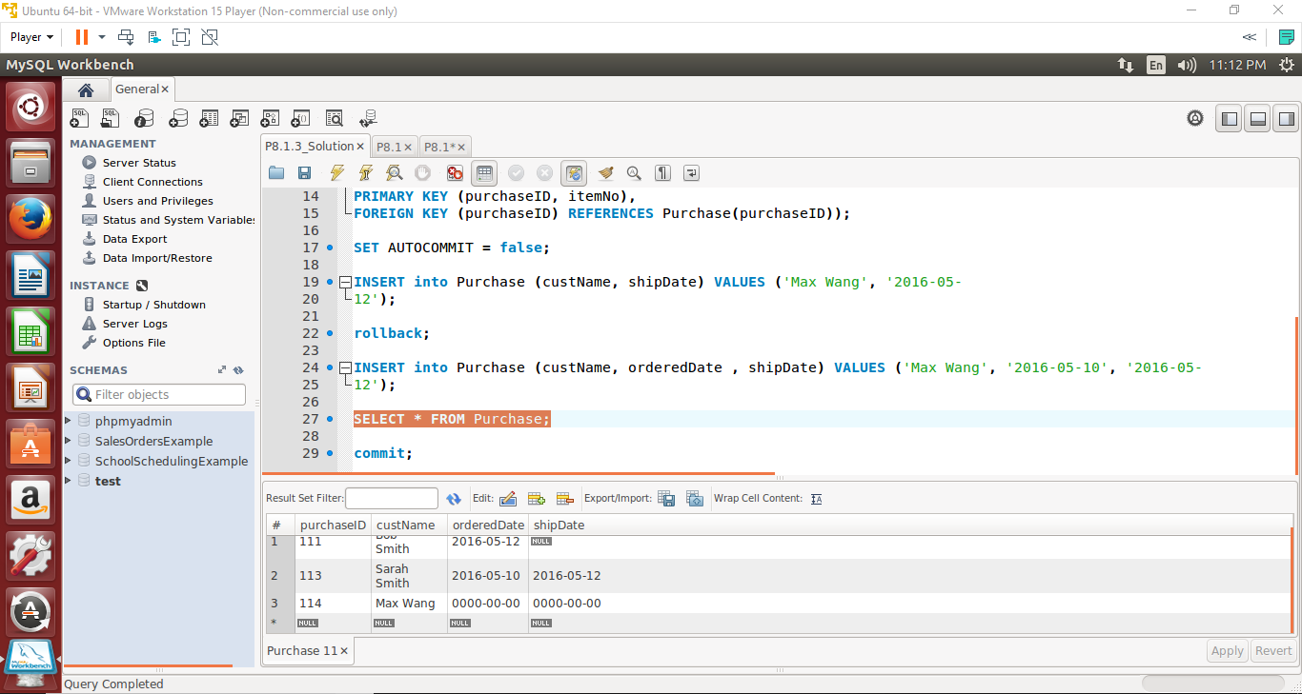

There is no value for orderedDate which is not nullable. The orderedDate must be added or the INSERT statement will not work.

